Massachusetts District Reviews

Comprehensive District Reviews

Introduction
Research on effective school and district leadership has highlighted the importance of a concerted districtwide focus on aligning each of the district’s systems in service of improving student achievement. This focus is demonstrated by clear standards for performance and goals for improvement, coupled with an ongoing cyclical process for measuring progress.
To that end, the Office of District Reviews and Monitoring (ODRM) at the Massachusetts Department of Elementary and Secondary Education (DESE) and its partner, the American Institutes for Research® (AIR®), provides a district review that assesses district systems, enabling district leaders to reflect on progress and strengthen performance. The focus of the district reviews is to provide formative and actionable feedback. These reviews are conducted according to Chapter 15, Section 55A of the Massachusetts General Laws.
The district review is designed to examine the systems, policies, and practices that drive the day-to-day work of the district, as well as those factors that may help or hinder staff performance and, ultimately, student performance and outcomes. Analysis of these systems, policies, and practices includes a focus on the ways in which the district works to improve and promote equity for all students.
The district review is intended to add value to the improvement cycle by providing an experienced team of education researchers who provide an objective analysis of the district’s systems and key findings on strengths and areas for improvement through an equity lens. The value of the district review is measured by the reflection that preparing and participating in the review promotes, the usefulness of the findings and recommendations to district leaders and stakeholders, the effectiveness of the resulting action steps and goals that the process generates, and, ultimately, improved results.
The comprehensive district review is an evidence-based process focusing on the Massachusetts District Standards and Indicators (DSI): Governance and Administrative Systems (Leadership and Governance, Human Resources and Professional Development, and Financial and Asset Management standards) and the Student-Centered Systems (Curriculum and Instruction, Assessment, and Student Support standards).

DESE’s District Standards and Indicators
The District Standards and Indicators, which are the basis for the comprehensive district review, clarify the components necessary to building strong systems that support student outcomes. The six District Standards and 21 Indicators were developed based on research and on input from Massachusetts school-, district-, and state-level stakeholders about policies, systems, and practices that, if implemented well, are likely to lead to improved student performance, opportunities, and outcomes. In particular, the District Standards and Indicators describe the focus on equity that all school districts must embrace to ensure they are effectively serving all students.
DESE has partnered with AIR to conduct comprehensive district reviews for selected districts. The comprehensive district review process includes data collection procedures, quantitative and qualitative analyses, and reporting. The goals for the comprehensive district review are to:
- Develop an evidence-based report which provides a snapshot of participating districts’ systems and practices relative to the Massachusetts District Standards and Indicators.
- Provide each district with key findings on strengths and areas for improvement through an equity lens, grounded in the Massachusetts District Standards and Indicators.
- Provide information to DESE to support the identification of relevant DESE resources specific to district needs.

The Comprehensive District Review Process
The superintendent or their designee serves as the district liaison and coordinates the review process on behalf of the district. The AIR district lead will serve as the primary point of contact for the district liaison throughout the district review process. The process includes the collection of a variety of types of data from a range of stakeholders and district documents. The multiple data sources allow analysts and writers to triangulate findings and provide a valid and reliable assessment of the district’s status on the District Standards and Indicators.
The comprehensive district review is primarily composed of four activities that include: 1) an optional district self-assessment, 2) document reviews, 3) instructional observations, and 4) stakeholder interviews and focus groups. Figure 1 provides an overview of the data collection activities and whether they are gathered on-site or through off-site data collection methods.
Figure 1. Overview of Data Collection Activities
Data Collection Activity | Description | Timing | On-Site | Off-Site
- District self-assessment (optional) | District staff will complete a self-assessment prior to the on-site visits. Choosing not to complete the self-assessment will not impact the findings of your district’s review. | Due to DESE by August 31 |  | X
- Document review | The district liaison or a designee will submit documents that provide information about systems and practices that are relevant to the standards. See Appendix B for a list of documents and Appendix C for directions to upload documents.  Note: Educator evaluation documents may be reviewed on-site or through access to the evaluation system (see Appendix D).  During the on-site stakeholder interviews and focus group sessions, the site visit team may request additional documents, as well as follow-up interviews, to address questions that emerge in evidence review, classroom observations, interviews, and focus groups. | Due to AIR at least two weeks prior to the on-site interview and focus groups |  | X
- Instructional observations | Certified observers will conduct classroom observations using the Classroom Assessment Scoring System (CLASS) observation tool. Observations will be conducted at each grade level. These can be scheduled at the same time as the on-site stakeholder interviews and focus groups or a few days prior or later. For more information on CLASS, see Appendix E. | 2-5 days | X
- Stakeholder interviews and focus groups | A team of three to four site visitors, led by the AIR district lead, will conduct interviews and focus groups with key stakeholders. A list of key stakeholders and a schedule will be collaboratively developed by the site lead and the district liaison. During this portion of the data collection, private space must be reserved. See Appendix F for a list of key stakeholders.  It is possible to hold some interviews and focus groups virtually to accommodate schedules. The AIR district lead and the district liaison will coordinate any virtual interviews and focus groups. | 2–4 days | X

Figure 2 provides a sample schedule for the Comprehensive District Review data collection.
Figure 2. Sample Comprehensive District Review Data Collection Schedule
Schedule | Activity
Prior to the district review | Orientation meeting. The AIR district lead and the district liaison meet virtually to discuss the process and the timeline for data collection.  Document collection begins. The district liaison begins gathering and uploading district documents.  District Self-Assessment submitted (optional)
Week 1 | District liaison/AIR district lead coordination. The district liaison gathers/uploads remaining documents and works with AIR district lead to coordinate on-site data collection and access to documents.
Week 2 | Data collection tasks  - Documents submitted  - Access to educator evaluation database provided  - Key Stakeholder Interviews and Focus Groups Schedule is finalized/confirmed  - Instructional Observation dates are confirmed, schedules are shared with the AIR district lead and school building leaders are notified of the schedule  - Superintendent interview completed (virtual)  - School maps and schedules submitted (for observations)
Week 3 | AIR district lead prepares the site visit team and reviews submitted materials.
Week 4 | On-site data collection. AIR site visit team conducts key stakeholder interviews and focus groups (2–3 days). (Some interviews and focus groups may be conducted virtually.)  AIR observers conduct instructional observations (2-4 days, depending on district size).

Analysis and Reporting
Team members will review, analyze, and triangulate data from documents, classroom observations, interviews, and focus groups. AIR considers all the evidence collected, makes connections, and looks for patterns and trends. Final reports include a description of the district context and background, demographic and student achievement data, findings focused on the district’s most significant strengths and challenges related to the District Standards and Indicators, and recommendations from DESE that the district can use for ongoing systematic improvement. Final reports also include instructional observation ratings at the grade and district level; ratings will be reported in aggregate and will not identify individual teachers.
Final reports are posted to https://www.doe.mass.edu/accountability/district-review/ upon completion In addition, in fall 2024, reports will be linked from each district’s accountability report on DESE’s School and District Profiles website.

Timeline
Comprehensive district reviews will take place between September and May.
In the fall, following an orientation session for all districts receiving a district review, each identified district liaison will be surveyed to prioritize the possible dates for the district’s review process. AIR will then confirm the date of the review, taking the district’s Massachusetts Comprehensive Assessment System (MCAS) testing schedule and other scheduling constraints into consideration.
The draft district review report will be submitted to ODRM for initial review and later to the district for factual correction prior to finalization. ODRM’s goal is to provide a draft report 3 to 5 months after the on-site visit. The time required to produce reports varies based on several factors.

Contacts
Robert Havdala  Office of District Reviews and Monitoring  Massachusetts Department  of Elementary and Secondary Education  Robert.J.Havdala@mass.gov | Betheny Lyke, EdD  American Institutes for Research  blyke@air.org

Appendix A.
Massachusetts Department of Elementary and Secondary Education District Standards and Indicators
Below are the six standards and their 21 related indicators. For a more detailed explanation of each indicator, please visit the DESE website.

Governance and Administrative Systems
Leadership and Governance
1. School Committee Governance
2. District and School Leadership
3. District and School Improvement Planning
4. Budget Development
Human Resources and Professional Development
1. Infrastructure
2. Recruitment, Hiring, and Assignment
3. Supervision, Evaluation, and Educator Development
4. Recognition, Leadership Development, and Advancement
Financial and Asset Management
1. Budget Documentation and Reporting
2. Adequate Budget
3. Financial Tracking, Forecasting, Controls, and Audits
4. Capital Planning and Facility Maintenance
Student-Centered Systems
Curriculum and Instruction
1. Curriculum Selection and Use
2. Classroom Instruction
3. Student Access to Coursework
Assessment
1. Data and Assessment Systems
2. Data Use
3. Sharing Results
Student Support
1. Safe and Supportive School Climate and Culture
2. Tiered Systems of Support
3. Family, Student, and Community Engagement and Partnerships

Appendix B.
Documents
The district liaison provides as many of the documents on this list as possible. Except for the Completed Curriculum List and Ratings Table and the Completed Assessment Inventory, districts are not required to create documents that do not already exist. Other pertinent information about the district that might inform the site visit team is welcome. Please be prepared during the site visit to provide additional documents that the site visit team might request. Individual student information should be redacted from all documents prior to submission.

Preparation Documents
- District organizational chart
- List of all administrators
- Completed Curriculum and Ratings Table
- Completed Assessment Inventory
For each school in the district:
- Map of school
- Daily schedule
- Master schedule

Core Documents
Leadership and Governance
- School committee minutes from past year (or web address where these are located)
- Strategic Plan, District Improvement Plan, and School Improvement Plans, as well as any district- or school-level plans related to ensuring educational equity for all students
- Sample agendas from relevant team meetings and schedules for the year (e.g., leadership team meetings, CPT meetings)
Financial and Asset Management
- Most recent budget proposal with any narrative/presentation used, and approved budget for past three years
- Capital plan
- Examples of data and financial reports provided to the school committee
- Financial audits (including, if applicable, annual single audit findings; End of Year Compliance Supplement; and any other recent financial management audits or review)
Human Resources and Professional Development
- List of all instructional staff and administrators who were scheduled to be evaluated during the during the previous school year (to facilitate random selection of educator evaluation files)
- Forms, documents, observation tools, and templates used in educator evaluation system for all educators, such as rubrics, educator plans, and observation and evidence gathering forms. Please also provide access to electronic documents related to educator evaluation in order for site-visit team members to review a sample of documentation. (If such access cannot be made available in advance, please plan to provide access during the on-site visit.)
- Teacher common planning time schedules
- Documents that describe/illustrate educator recognition, leadership development, and advancement program(s) and opportunities
- Description of induction and mentoring program and/or associated handbook/materials
- Professional Development (PD) Plan and description of current PD program, along with documents or data illustrating evaluation of PD, including curriculum-specific professional development plans for all grades
- Human Resources office procedures manual and any other associated materials, particularly those articulating recruitment, hiring or placement procedures
Curriculum and Instruction
- Curriculum pacing guides, scope and sequences, and sample curriculum documents or curriculum units of study for English language arts, mathematics, science and technology/engineering, and history and social science for all grade levels. (The district may also choose to provide access to curriculum posted online.)
- Description of the curriculum review process (e.g., identification, piloting, adoption) and calendar/schedule, if applicable
- High school program of studies
- Most recent New England Association of Schools and Colleges (NEASC) report, if applicable
Assessment
- Documents that describe or illustrate structures, policies, or practices related to data analysis and use (e.g., description of the district data team; protocols used for data analysis at the district, school, or classroom levels)
- Copies of data analyses or reports used in schools, such as analyses of student performance on mid-term and final examinations and benchmark and formative assessments
Student Support
- Description of Tiers 1, 2, and 3 academic, behavioral, and social-emotional supports for all students
- District Curriculum Accommodation Plan (DCAP) or document that provides general education teachers with guidance to address the needs of students with diverse learning styles and needs
- Documents that describe or illustrate district- and school-based student support teams or similar teams that meet regularly to discuss student academic, social-emotional, and behavioral needs
- Guidance for schools about how to engage with families; information about opportunities for family leadership (e.g., Special Education Advisory Council, School Advisory Council)
- Examples of ways in which the district shares student performance data with students and families
- Internal and external evaluations of mandated programs (such as English learners, special education, and Title I) and of other programs and services (such as needs assessments, community partnerships, and curriculum reviews)
- Documents that describe or illustrate the district’s My Career and Academic Plan (MyCAP) process (including scope and sequence), or that describe/illustrate a similar student-driven process which provides students with ongoing opportunities to plan for their academic, personal, or social and career success
- Documents that describe or illustrate the way in which the district assesses school climate and conditions for learning within the school (e.g., extent to which the school environment is safe, supportive, culturally responsive, engaging, and equitable), as well as any relevant data (examples include the Multi-Tiered System of Support (MTSS) Self-Assessment, the Safe and Supportive Schools Self-Reflection Tool, the School Health Assessment and Performance Evaluation System (SHAPE), or an action plan addressing school climate)

Appendix C.
SharePoint Directions

Uploading Files to SharePoint
- Provide your AIR district lead with email addresses for one or more district representatives who will be responsible for providing documents for the district review and thus need access to SharePoint. Note: Only authorized individuals will have access to the SharePoint.
- You will receive an email sharing a folder with you. (This email may go to your Spam or Junk folder, so please check those folders if you are expecting the invitation.) Click on the folder icon or the Open button to open a folder.

- Note: You may need to create a Microsoft account to access the site. You may have difficulty accessing the site if you use a Microsoft account that already is linked to another organization. If you have any difficulty connecting to the folder, please contact your AIR district lead.
- You should then receive a prompt for two-factor authentication. Click Next.
- Select your preferred method of contact (text, call, or mobile app) for two-factor authentication.
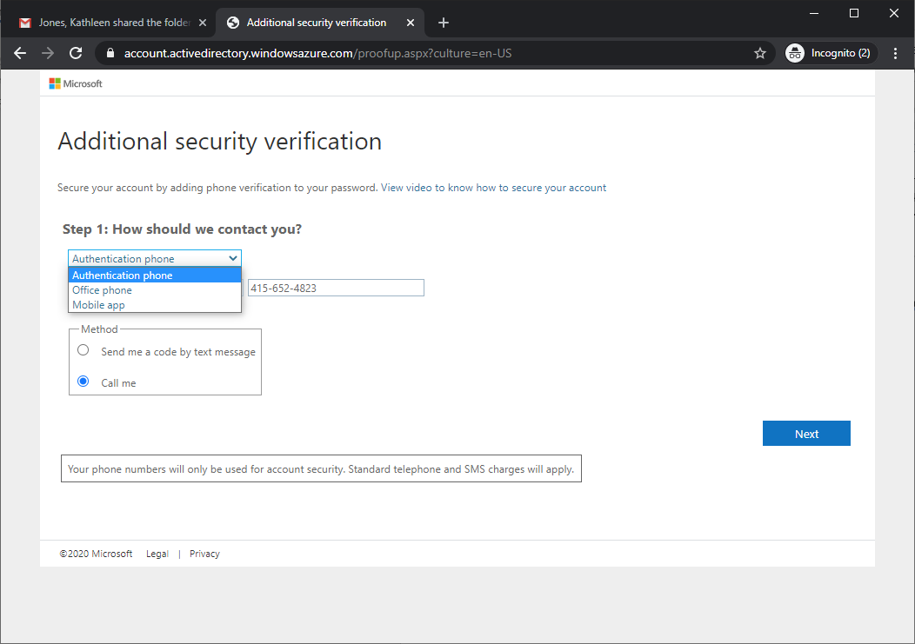
Click Next and enter in the code as prompted.
- Click Done, and you will be taken directly to the folder for your district (only authorized users from your district and the AIR site-visit team will have access to this folder).

- On the SharePoint site, click upload and select the file or files you want to upload. Folder permissions ensure that personnel from each district can only view their own district’s documents. Please be sure that all documents are titled in such a way that the content of the document is clear.
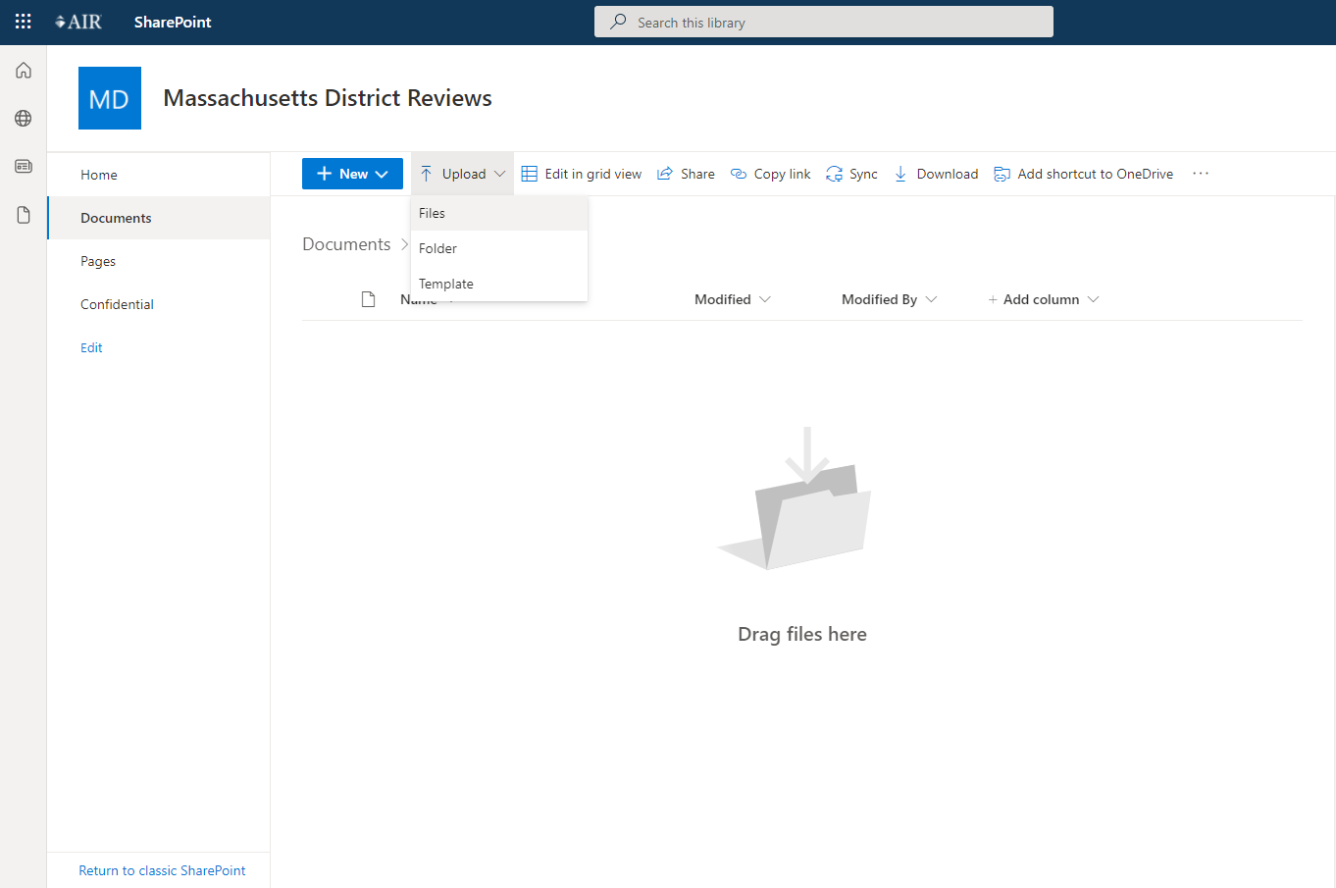
If the documents are already stored in a folder or directory structure, you may upload the complete structure.

Having Difficulty?
If you are signed into a SharePoint, OneDrive, or Microsoft account with an email address that differs from the email address that received the AIR SharePoint Online invitation, please sign out of the account before clicking on the SharePoint Online folder link in the email from AIR.
If you have any questions about the document collection process or using the SharePoint, please contact Betheny Lyke (BLyke@air.org).

Appendix D.
Educator Evaluation File Review
Because a district’s systems for continually building educator effectiveness are critical to improving student achievement, the review includes a careful analysis of educator evaluations, following the guidelines below.

- Based on the number of teachers working in the district, the site-visit team identifies a group of teachers and asks to see the following documents for each of them:
- Teacher self-assessment
- Educator Plan, including professional practice and student learning goals
- Announced or unannounced observation reports
- Formative assessment or evaluations
- Summative evaluations (also called teacher evaluations) for teachers who were evaluated during the previous school year
- In addition, the site-visit team will ask to see the following documents for each currently serving administrator, including the superintendent:
- Self-assessment
- Educator Plan, including professional practice and student learning goals
- Observation or school visit reports or documentation
- Formative assessment or evaluations
- Summative evaluations (also called administrator evaluations) for administrators who were evaluated during the previous school year
If records are stored electronically, the district should provide electronic access for the assigned members of the site-visit team. If paper documents are stored, hard copies should be provided or scanned and submitted electronically.
The site-visit team recognizes that in many districts, only about half the teachers and half the administrators are being evaluated each year in accordance with the educator evaluator requirements.

Appendix E.
Instructional Observations and CLASS Information
Site review team members who observe the classrooms all receive training on the CLASS protocol in a two-day session and pass a rigorous certification exam to ensure that they can accurately rate the dimensions.
Table E1. CLASS K–3 Domains and Dimensions
Emotional Support | Classroom Organization | Instructional Support
- Positive Climate  - Negative Climate  - Teacher Sensitivity  - Regard for Student Perspectives | - Behavior Management  - Productivity  - Instructional Learning Formats | - Concept Development  - Quality of Feedback  - Language Modeling
Table E2. CLASS Upper Elementary Domains and Dimensions
Emotional Support | Classroom Organization | Instructional Support
- Positive Climate  - Teacher Sensitivity  - Regard for Student Perspectives | - Behavior Management  - Productivity  - Negative Climate | - Instructional Learning Formats  - Content Understanding  - Analysis and Inquiry  - Quality of Feedback  - Instructional Dialogue
Student Engagement
Table E3. CLASS Secondary Domains and Dimensions
Emotional Support | Classroom Organization | Instructional Support
- Positive Climate  - Teacher Sensitivity  - Regard for Student Perspectives | - Behavior Management  - Productivity  - Negative Climate | - Instructional Learning Formats  - Content Understanding  - Analysis and Inquiry  - Quality of Feedback  - Instructional Dialogue
Student Engagement
When conducting a visit to a classroom, the observer rates each dimension on a scale of 1 to 7. The ratings of all classrooms visited in a school will be aggregated for each domain and dimension in the district review report. Names of teachers whose classrooms are observed are not recorded and will not be reported.

Appendix F.
Key Stakeholders for Interviews and Focus Groups
Guided by the District Standards and Indicators, interview (I) and focus group (FG) questions will be customized for specific stakeholders. Interviews and focus groups will take approximately 45-60 minutes. Stakeholders participating in one of these may include the following:
- Superintendent (I)
- District leaders who lead work in each district standard (I)
- School leaders (FG)
  - One focus group
  - All principals in the district
- School-level instructional staff (FG)
  - Multiple focus groups
  - General education teachers
  - Special education specialists
  - English learner specialists
- School committee members (FG)
- Teachers’ association leadership (FG)
- Family members (FG)
- Students (FG)
  - Multiple groups
  - Middle and high school students
Stakeholder(s) | Type | Optimal Number of Participants
Superintendent | Interview
District leaders | Interviews | As required
School leaders | Focus group(s) | All school leaders in district
Instructional staff | Focus groups | 6–8 per group
School committee members | Focus group | 3+
Teachers’ association leadership | Focus group | 1–5 leaders
Family members | Focus groups | 1-2 focus group with 3–5 families each
Students (middle and high school) | Focus groups | 2 focus groups, 6–8 students each

See Appendix A for an abbreviated list of District Standards and Indicators.
The estimate is based on a district with five or fewer schools. Instructional observation data collection may take additional days for larger districts. The AIR site lead will coordinate with the district liaison to determine the best strategy for collecting these data.
The review of evaluations as part of the district review process is mandatory for each district receiving a Comprehensive District Review and is allowable under state regulations (603 CMR 35.10 (2)). Both DESE and AIR staff understand the sensitive nature of this information and are committed to ensuring its confidentiality in the development of the district review report.
This may be broken into two focus groups if there are more than six schools in the district.
Permission forms for each student must be signed by a family member and submitted to AIR staff before student groups occur. AIR district lead will provide these blank forms to the district liaison.

